Five-a-day starter
Week commencing 6/6
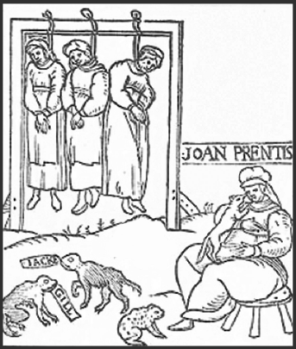
An illustration from a pamphlet printed in 1589 about three women who were hanged as witches. It also shows one of them, Joan Prentis, with her familiars.
What is the purpose of this source?
Describe details from the source:

What the source is trying to do:

(Ext) Why the source was drawn in 1589:

Change over time:  How and why did methods of punishing vagabonds change between 1350 and the Tudors? | How they changed:  (Extension) Why they changed:
Write definitions for the key words:
- Elizabeth Fry
- Bow Street Runners
- Bloody Code
- Tithing
- Witchcraft
Put these examples of law enforcement in chronological order:
Legionaries, police cars, tithings, Bow Street Runners, watchmen.
Context  List THREE ways that the Anglo-Saxons used the community as law enforcement:  Ext: Why did it work? | 1.  2.  3.

