Five-a-day starter
Week commencing 6/6
“The cruelties of Ilchester Gaol” from a pamphlet published in 1821.
What is the purpose of this source?
Details from the source:

What the source is trying to do:

(Extension)Why the source was drawn in 1821:

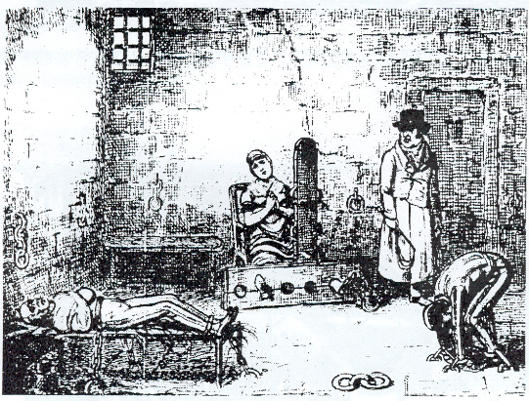

Change over time:  How and why did methods of policing change between the Anglo-Saxons and the Tudors? | How they changed:  (Extension) Why they changed:
Write definitions for the key words:
- Murdrum
- Trial by Ordeal
- Arson
- Highway robbery
- Heresy
Put these in chronological order:
Tudors, Normans, Metropolitan Police Force, peak of witchcraft trials, end of transportation

Context  List THREE reasons for the end of the Bloody Code | 1.  2.  3.

