Five-a-day starter
Week commencing 20/6
An illustration showing Elizabeth Fry reading to prisoners at Newgate prison, 1823.
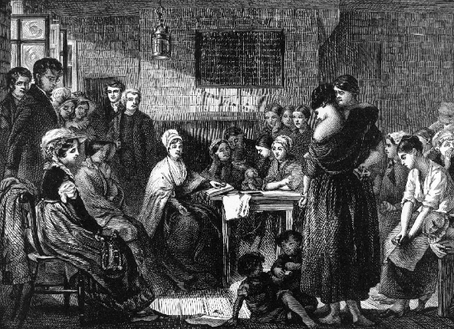
What is the purpose of this source?
Describe details from the source:

What the source is trying to do:

(Ext) Why the source was drawn in 1823:

Change over time:  How and why did methods of law enforcement (policing) change between 1700 and 1900? | How they changed:  (Ext) Why they changed:
Write definitions for the key words:
- Black Act
- Trial by combat
- Capital crime
- Pointless work
- Hue and cry
Put these examples of punishments in chronological order:
Hanging drawing and quartering, execution in prison, transportation, drinking molten lead, tithing.
Context  List THREE reasons why laws against poaching were so harsh in the 18th century. | 1.  2.  3.

